American University of Science and Technology
Faculty of Engineering
Department Of Computer and Communication Engineering

Electronics Lab
Power Supply with a Transistor

Submitted to
Dr. Adel Chit

Beirut, Lebanon

Contents
Introduction 2
Schema 2
Materials 2
IMPLEMENTATION 2
Results and Discussions 3
Applications: 3
Conclusion 3
References 3

Introduction
In the eighth project we built a power supply using a it gives as a variable DC output between 0V and 30V.

Schema
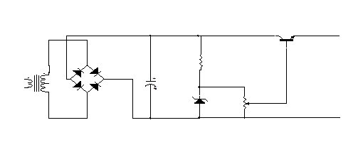

Materials
- Transistor (2N222)
- Zener diode 15V
- Bridge rectifier (1A)
- Transformer 12V-0V-12V
- Capacitor
  - 3 0.1uF non polarized
  - 1 470uF polarized capacitor
- Resistor: 330 Ω
- Pot of value 4.7K Ω

IMPLEMENTATION
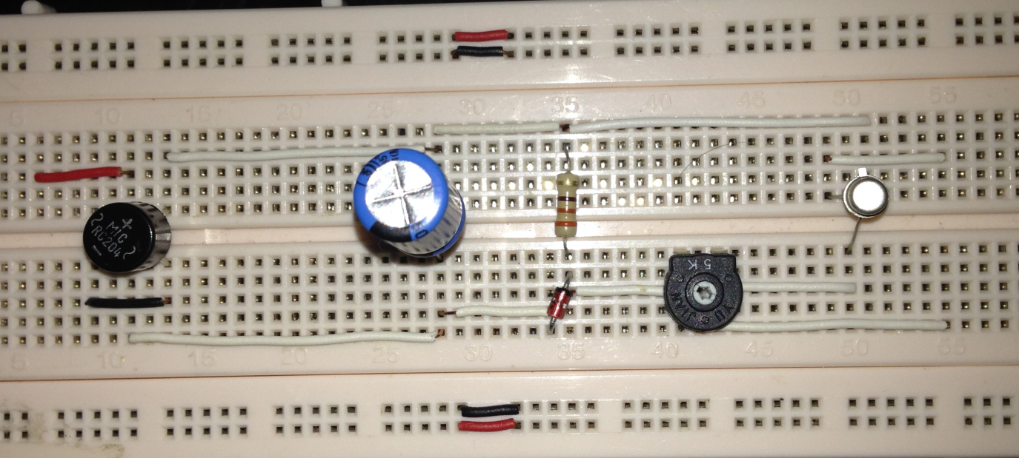

Results and Discussions

We have got the desired DC voltage of a variation ranging from 0V through 30V that changes as we change the potentiometer.

Applications:
- Supplying a DC voltage applications varying (0V 30V)
- op-amps circuits and Microcontrollers (5V usually)

Conclusion
The theoretical studies were compatible with the results that we got upon testing our circuit we capable to have a variable dc output varying between zero volt and thirty volt it varies according to our needs as we vary the value of the variable resistor that functions as a voltage divider

References
Electronic Devices, Conventional Current Version. Thomas L. Floyd.

